Ingenic Studio User Guide

## Startup Ingenic Studio

In order to use Ingenic Studio, please run eclipse.exe program in IngenicStudio folder. It will show a splash dialog like that:



Then, the workspace launcher will ask you the workspace directory, you can use the default setting and click “OK” button.

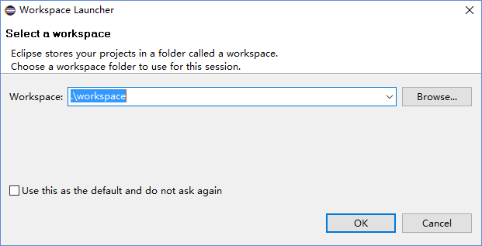

## Create X1000 Project with RT-Thread RTOS

Please use menu: File 🡪 New 🡪 X1000 Project to create a new X1000 project with RT-Thread RTOS support.

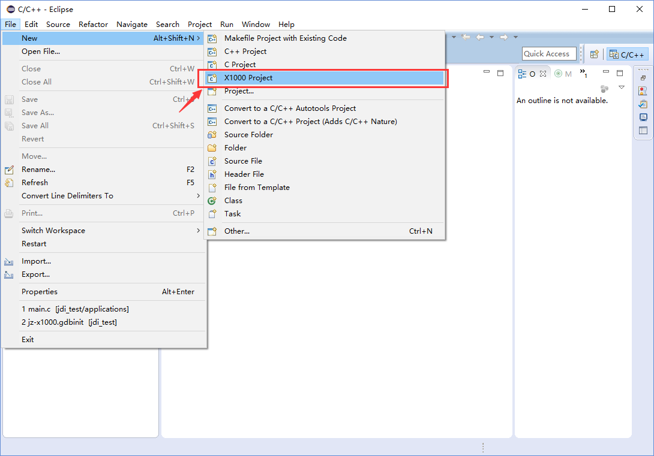

Please select X1000(RT-Thread) project and select **“Cross MIPS GCC”** in toolchains setting. Then provide a name text in Project name, such as “X1000”:

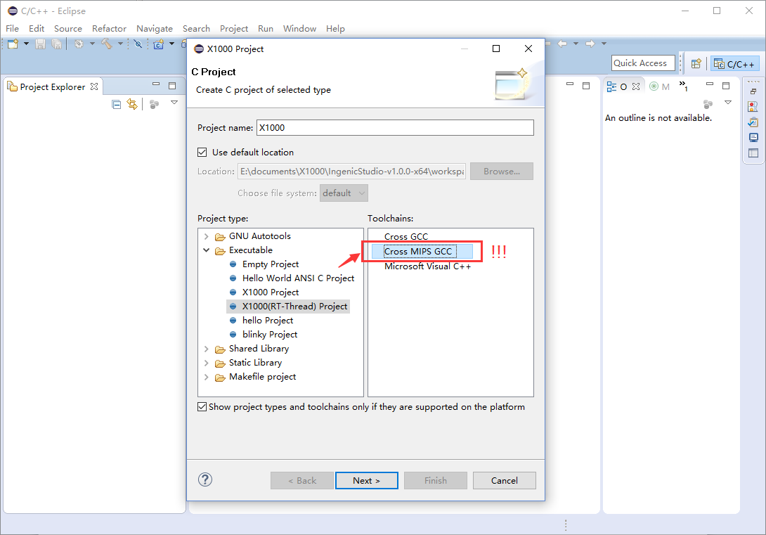

(Please pay attention the Toolchains setting. You must select **“Cross MIPS GCC”**)

Please click “Next” button to enter the “Select Configurations” dialog.

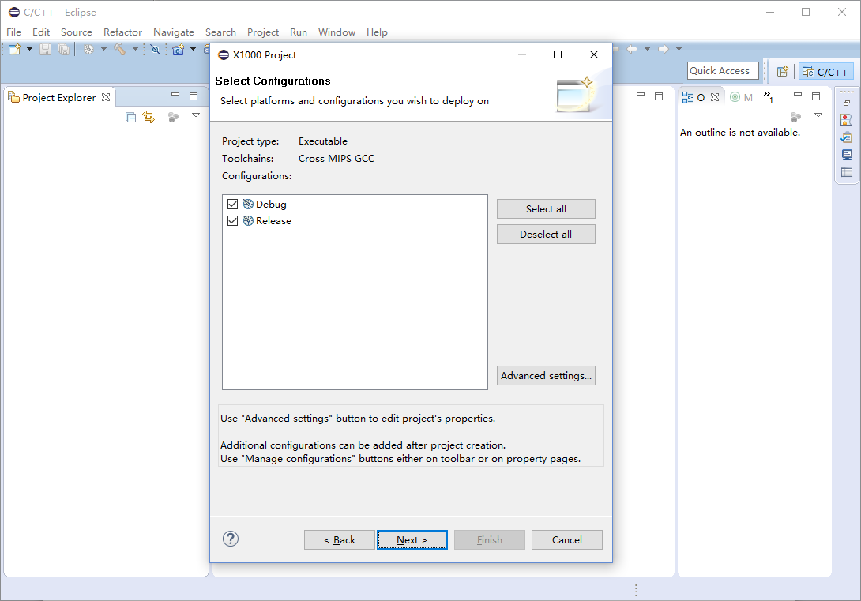

Please use the default setting and click “Next” button for next step.

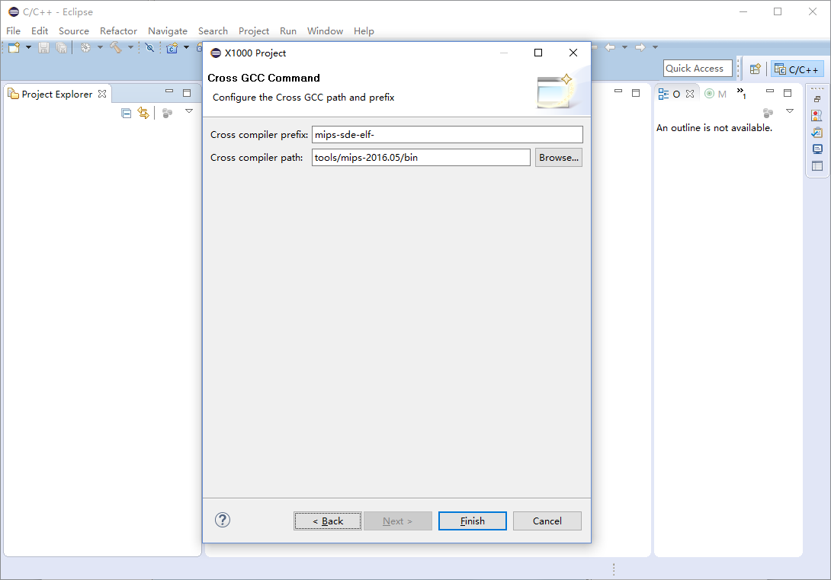

Please use the default setting and click “Finish” button to create a new project.

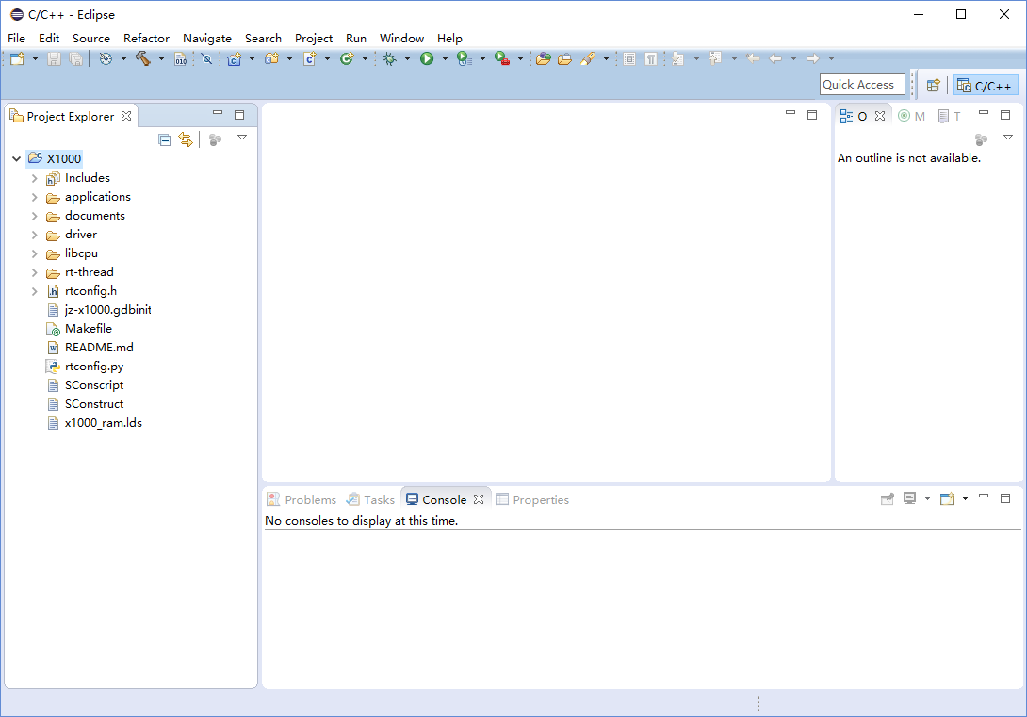

## Compiling Project

When X1000 with RT-Thread RTOS supported project has been created, you can build the project directly by menu Project 🡪 Build Project, or use the shortcut key: Ctrl+B.

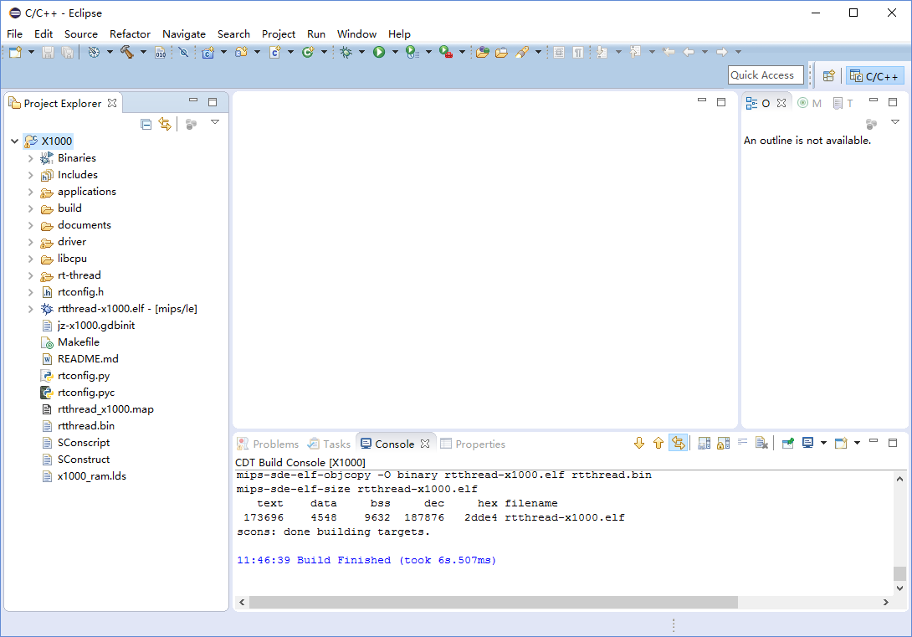

## Debug with JDI Emulator

### 4.1 Connect JDI Emulator

When you debug your program with JDI emulator, please ensure the JDI and the target device is connected: please use a micro-b USB cable to connect JDI and you PC. And use the JTAG cable to connect your board.

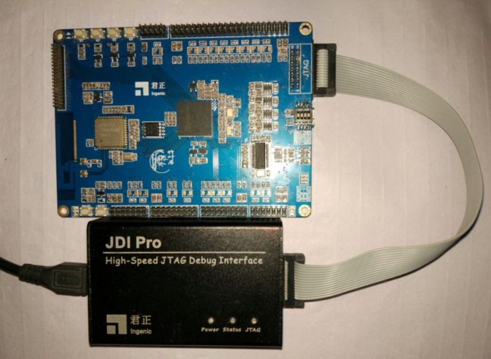

The JTAG connector in JDI is descripted in following figure:

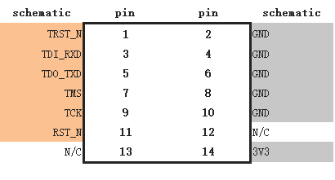

Please make sure the TDI/TDO/TMS/TCK and RST_N, GND are correctly connected.

When you connect JDI emulator to PC, an USB device should be found in PC side. Please install the JDI driver, which is located in IngenicStudio\tools\JDI Pro folder. If you use Win8/10, please make sure PC turn off the driver digital signature. When the JDI driver installed successfully, there is a virtual network card in device list of your PC, for example:

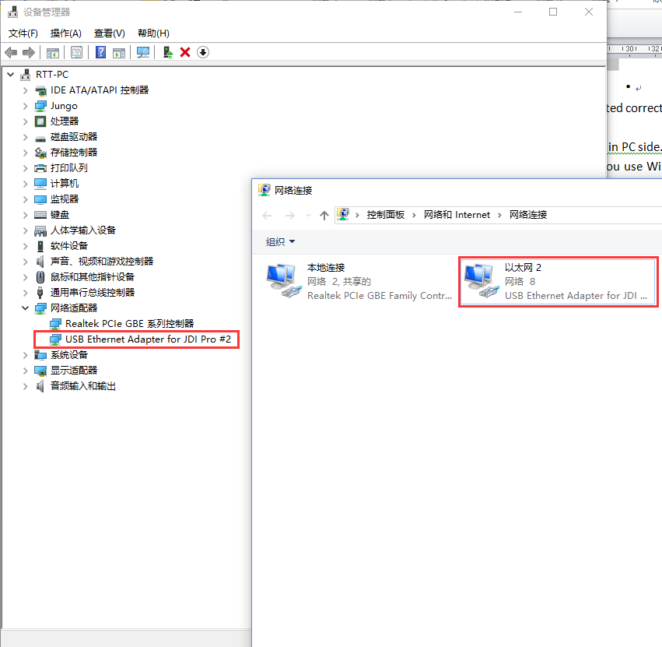

Please view the status of this network device and record the gateway address,

eg:

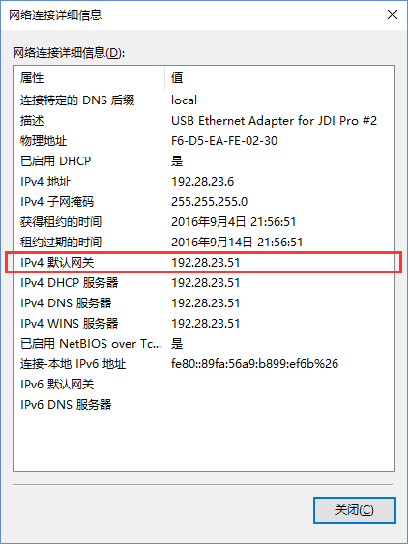

(Please pay attention on the IPv4 gateway address: 192.28.23.51)

### 4.2 Setup Debug Environment

Open Ingenic Studio, in the menu: Run-> Debug Configurations…

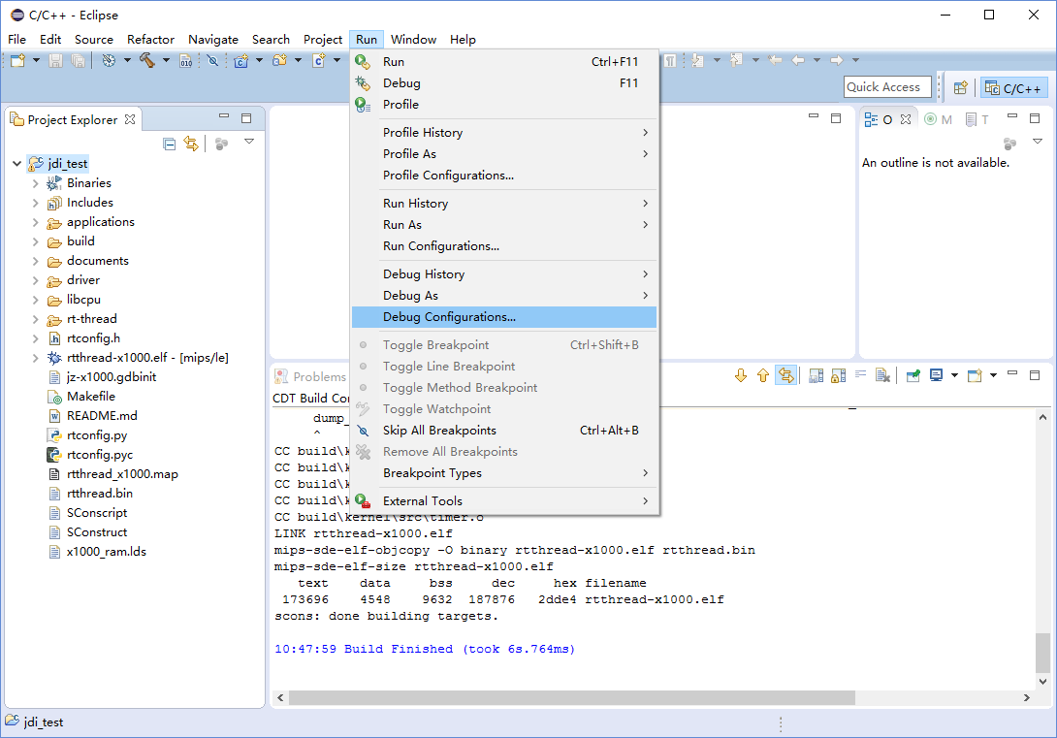

In the debug Configurations dialog, please select “Zylin Embedded debug (Native)” and then double-click it.

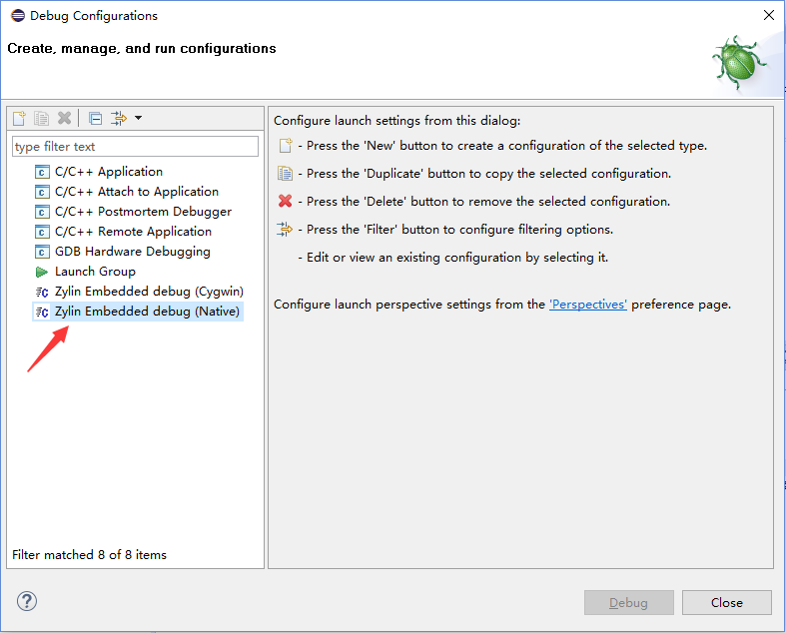

Then it will create a new configuration:

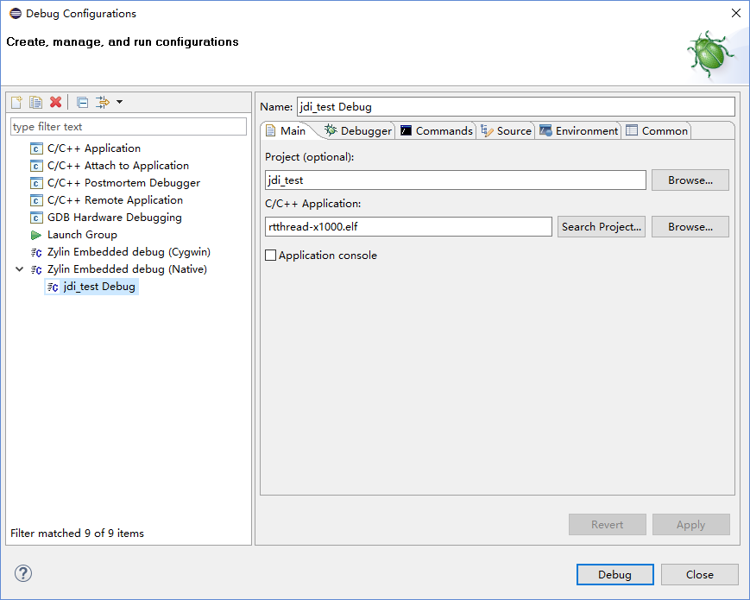

In the Debugger tab page, you should setup gdb.exe and the GDB initialization script file path.

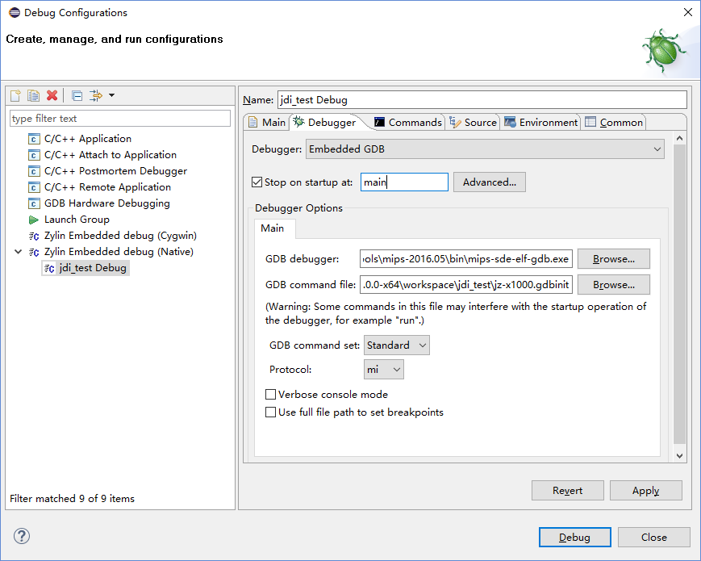

* The “mips-sde-elf-gdb.exe” is placed in Ingenic Studio\tools\mips-2016.05\bin folder.
* The “jz-x1000.gdbinit” is placed in your workspace folder.

In convenience, you can let the debug item display in favorites menu (In Common tab page), selected the “Debug” item.

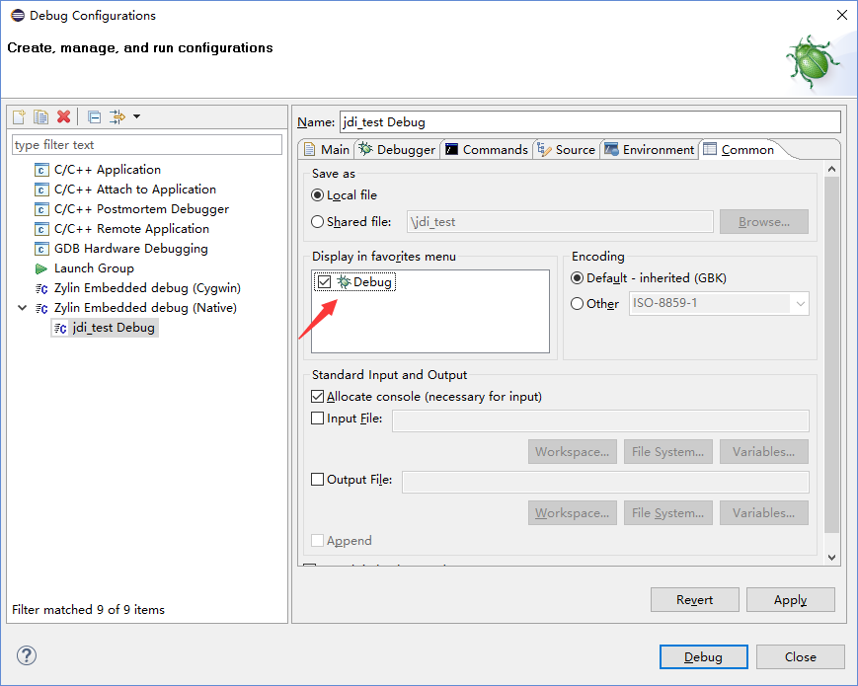

Then you can click “Close” button and confirm the configuration by “Yes” button:

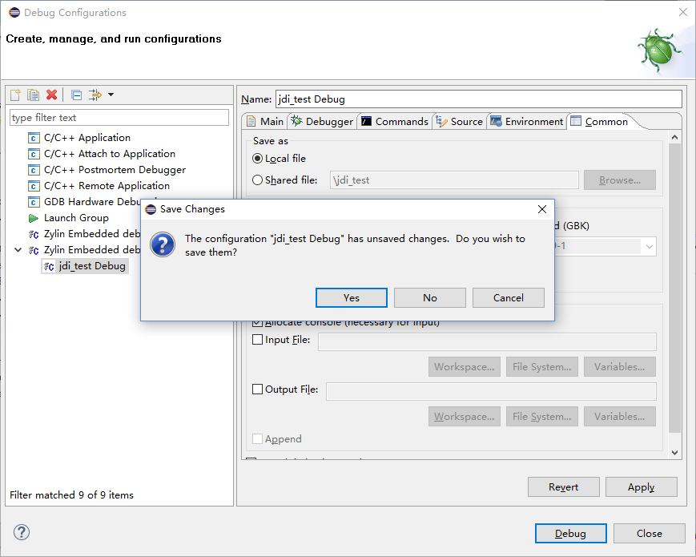

### 4.3 The GDB initialization script

The jz-x1000.gdbinit is the GDB initialization script when GDB starting. You can open it in Ingenic Studio editor:

# connect to the JDI gdb server

target remote 192.28.23.51:2823

#set remote write size

set remotewritesize fixed

set remotewritesize 8192

#load the debug image

load

#debug begin

Please pay attention in the red font part, the “192.28.23.51:2823” is the JDI emulator IP address. The “192.28.23.51” is the gateway address in new virtual network interface card and “2823” is the “GDB server” port in the JDI emulator.

### 4.4 Startup Debug

Please click your new created debug configuration item, for example, “jdi_test Debug”:

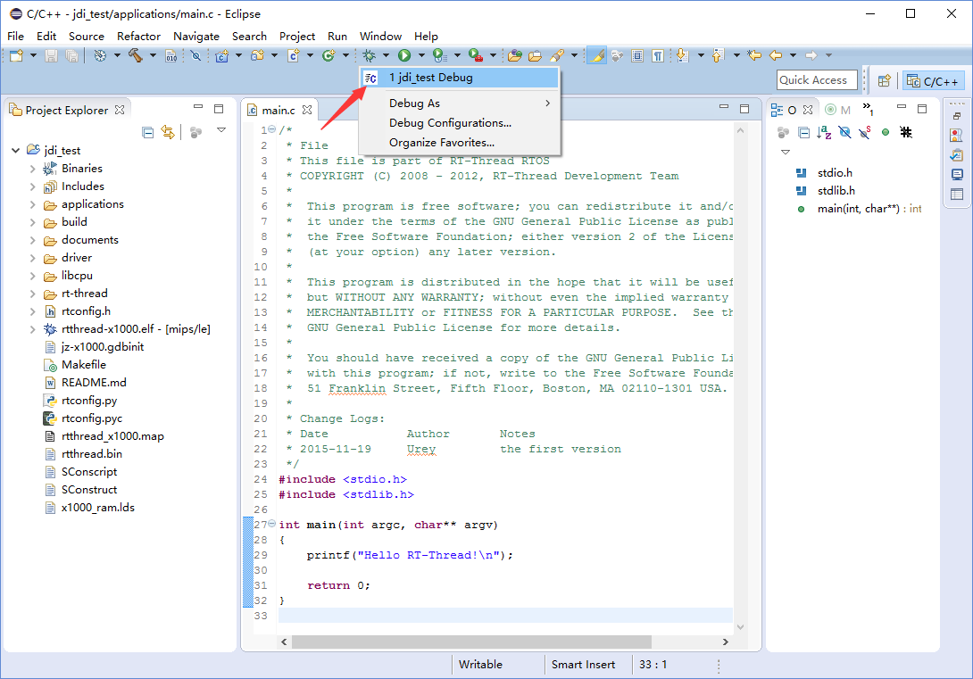

There is a confirm dialog to confirm whether switch to Debug perspective, please click “Yes” button.

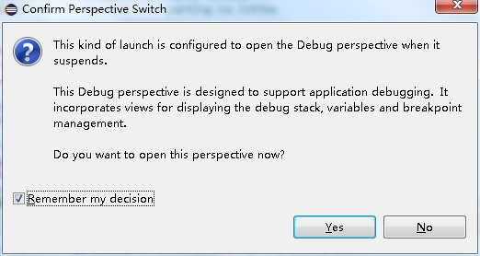

When JDI emulator connected successfully, the UI likes that:

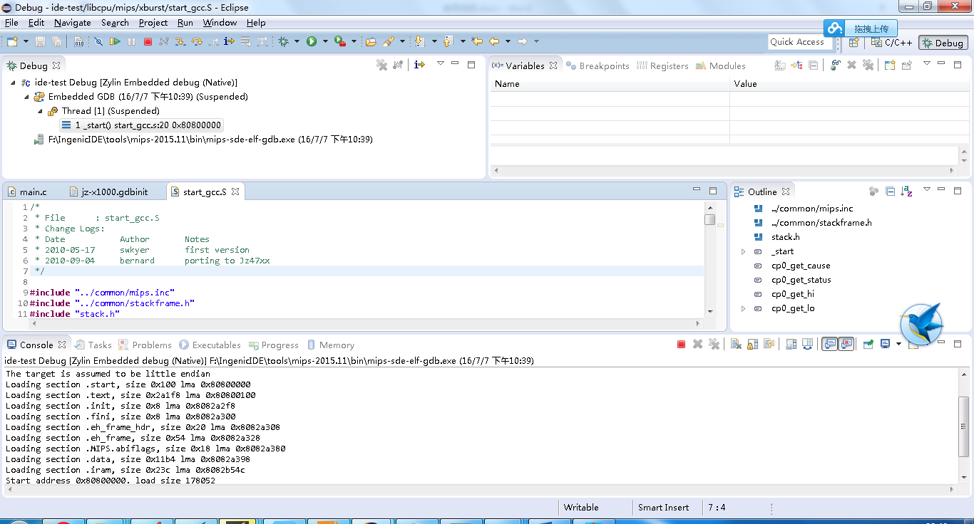

Then you can debug your program, such as step in/step over, or inspect variable, function call stack etc.